1. Query to find the title of each film

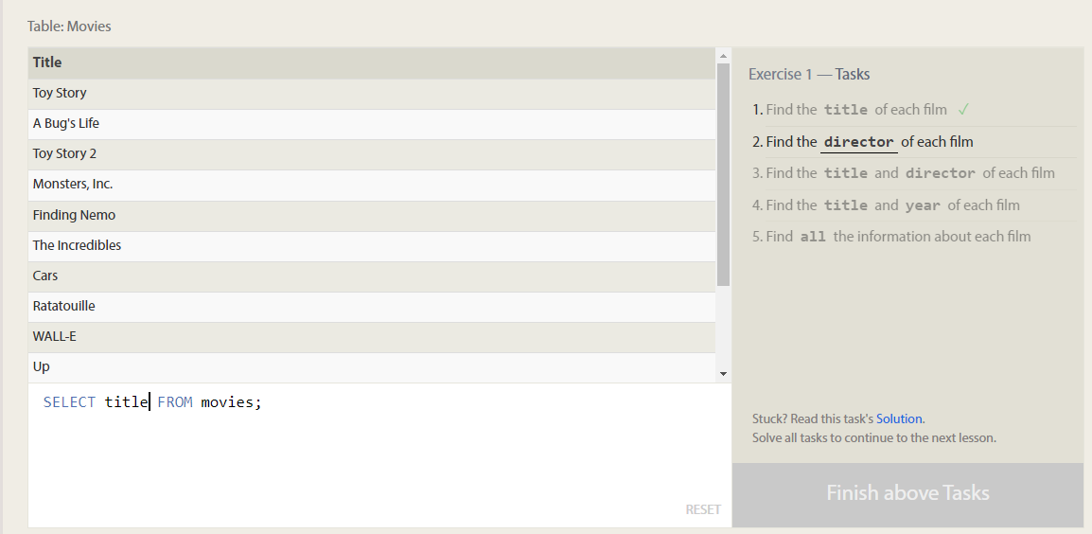

1. Query to find the director of each film

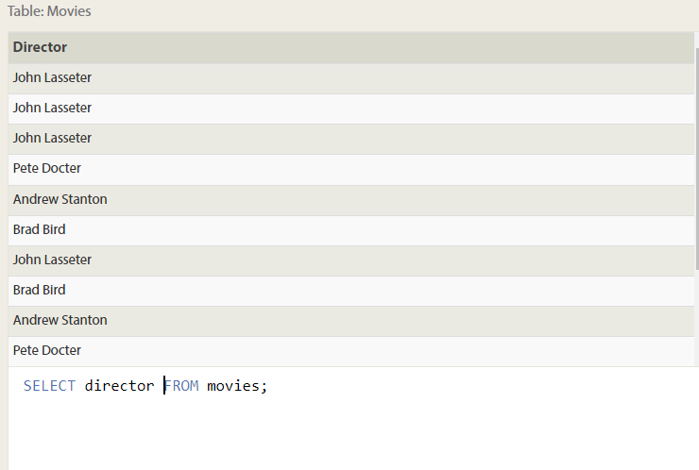

1. Query to find title and director of each film

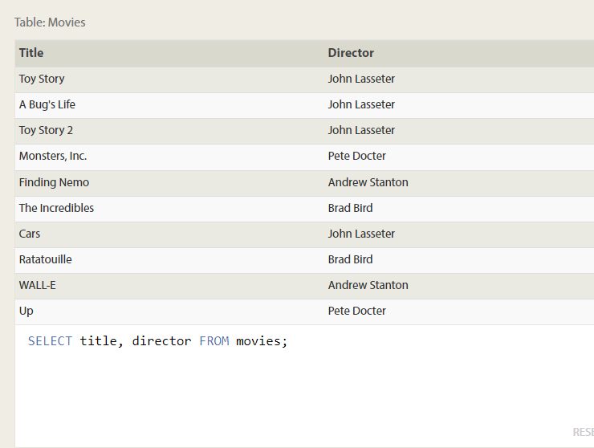

1. Query to find the title and year of each film.

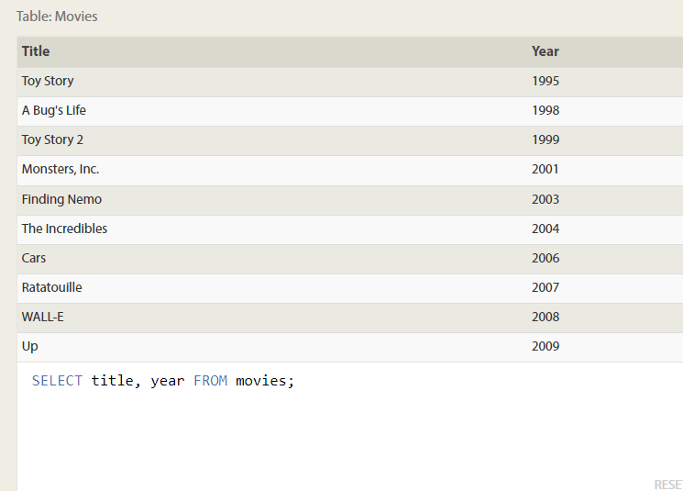

1. Query to find all details.

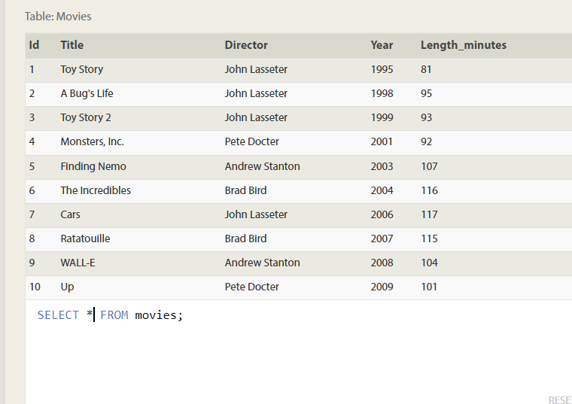

1. Query to find movie with id 6

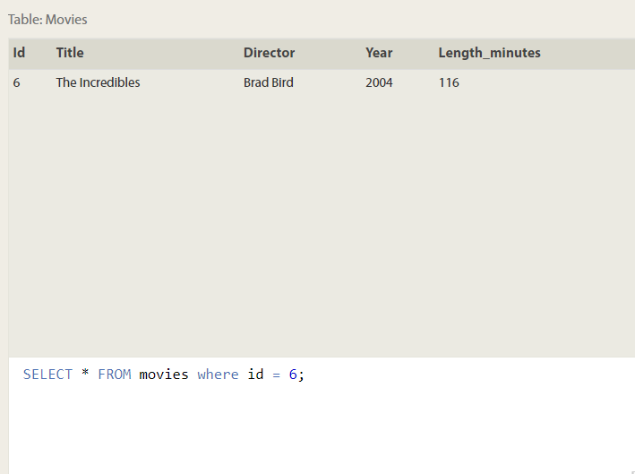

1. Query to Find the movies released in the **year**s between 2000 and 2010

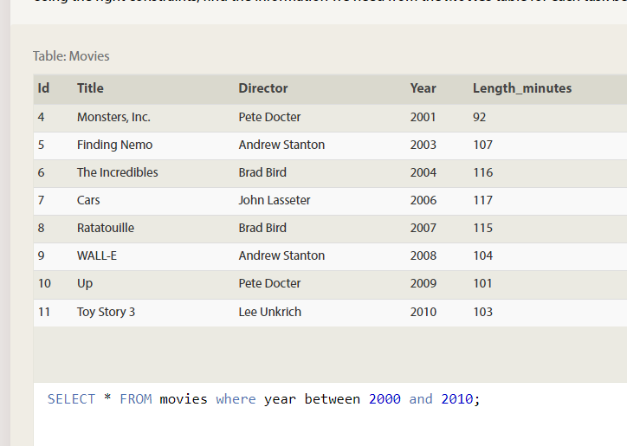

1. Not released between 2000 and 2010

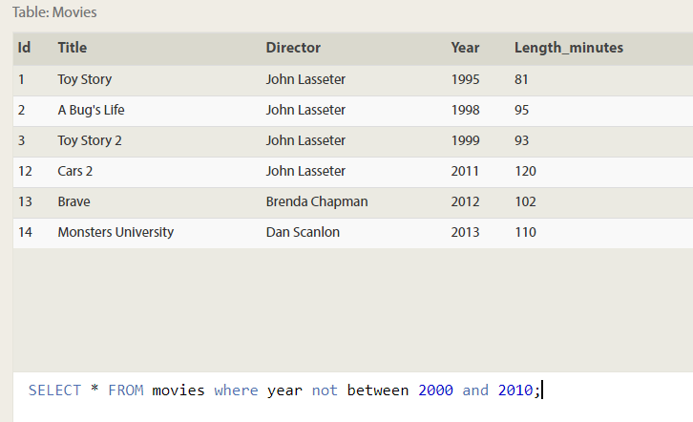

1. First 5 pixar movies and their release year

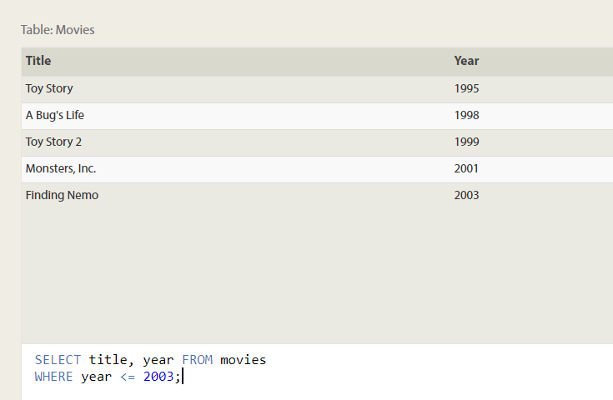

1. Find all toy story movies

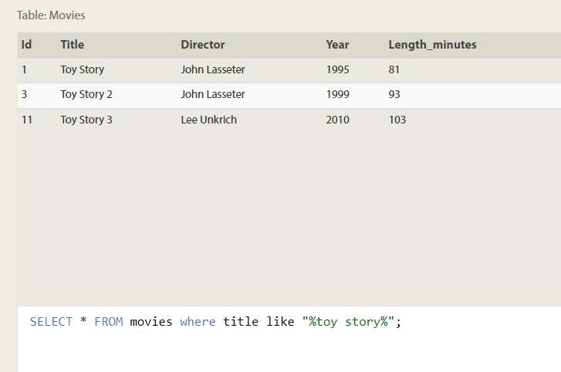

1. Movies directed by john Lasseter

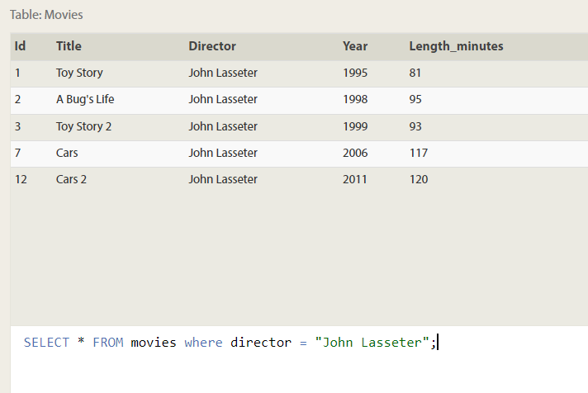

1. Not directed by john Lasseter

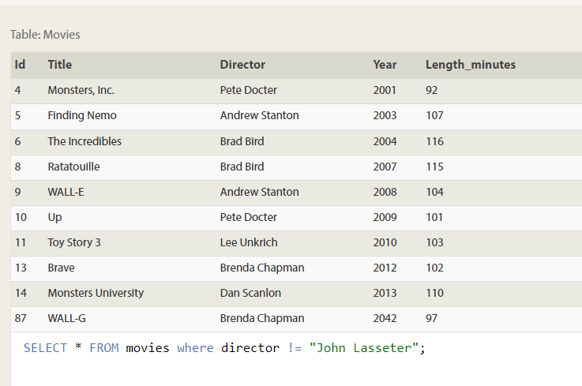

1. Wall*-movies

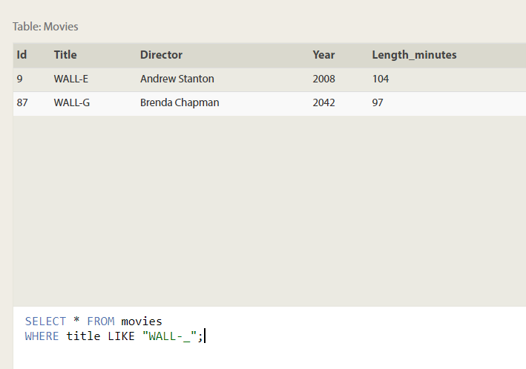

1. Listing directors alphabetically without duplicates

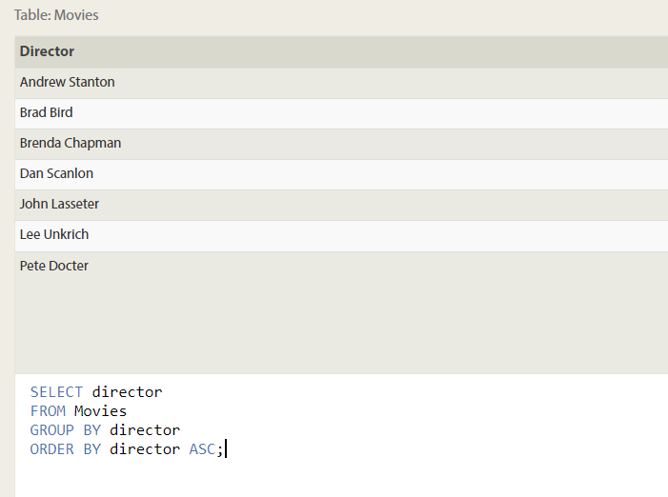

1. List of last 4 pixar movies released

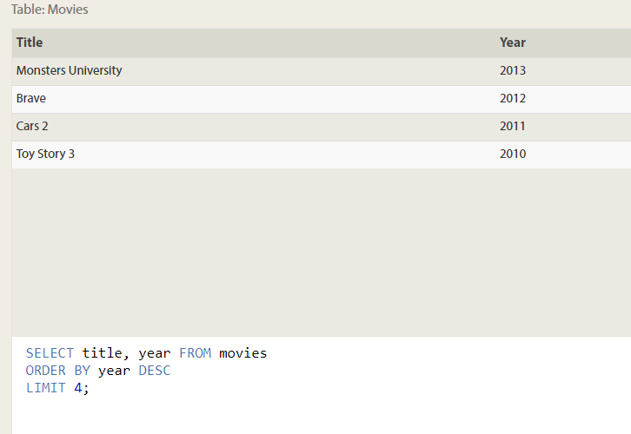

1. First 5 pixar movies sorted alphabetically

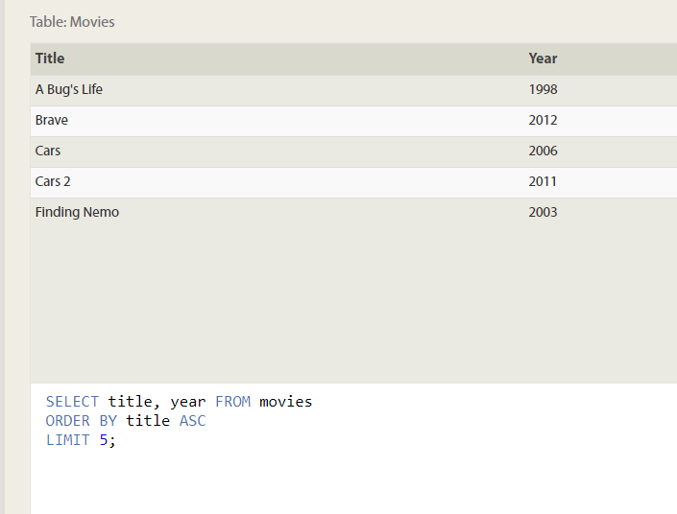

1. NEXT 5 PIXAR MOVIES

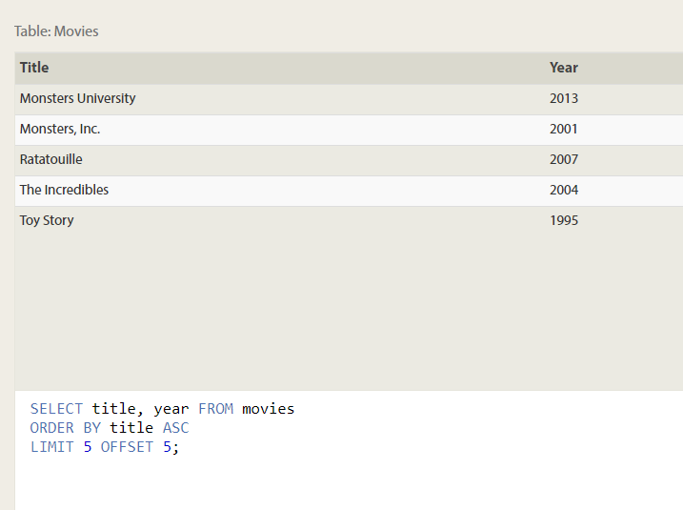

1. Canadian cities and their population

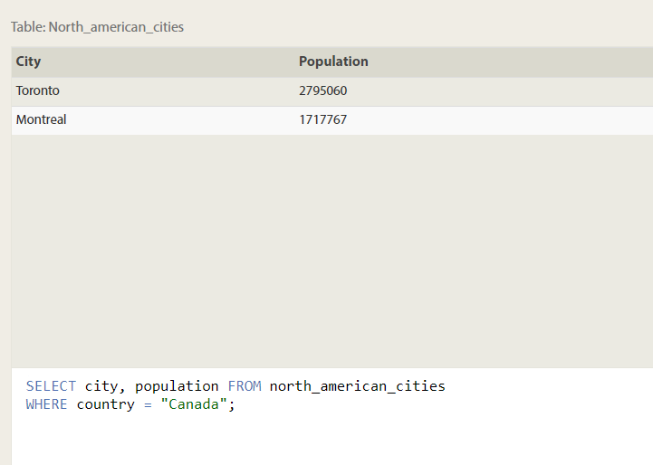

1. List of cities to the west of Chicago

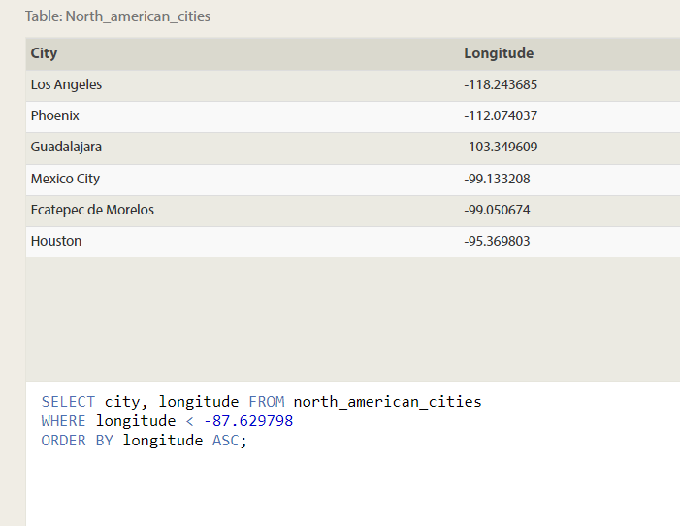

1. Two largest cities in Mexico by population

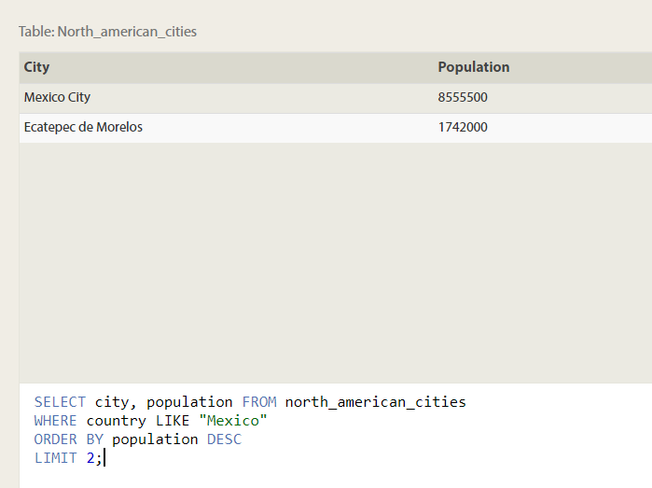

1. 3rd and 4th largest cities by population in united states

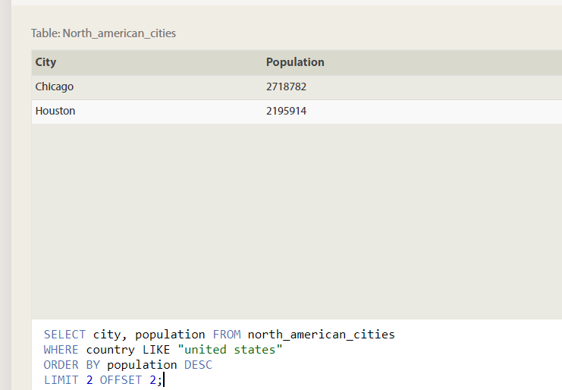

1. Domestic and international sales for all the movies

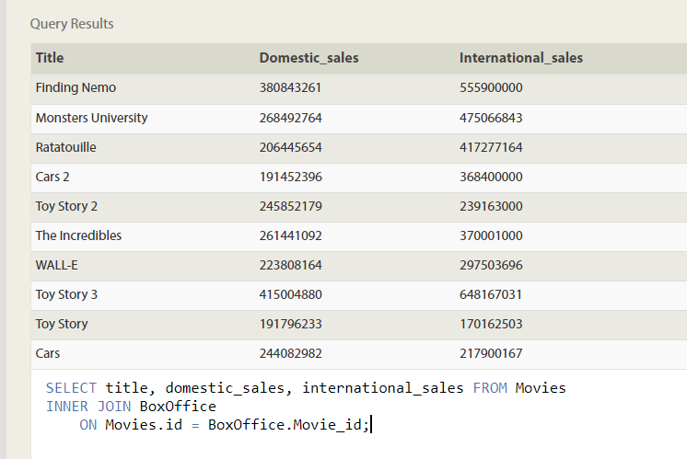

1. Sales number that did better internationally than domestically

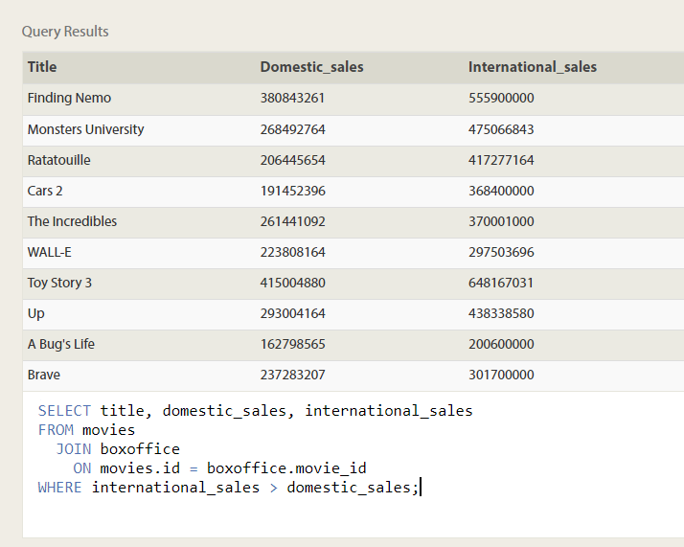

1. Ratings in descending order

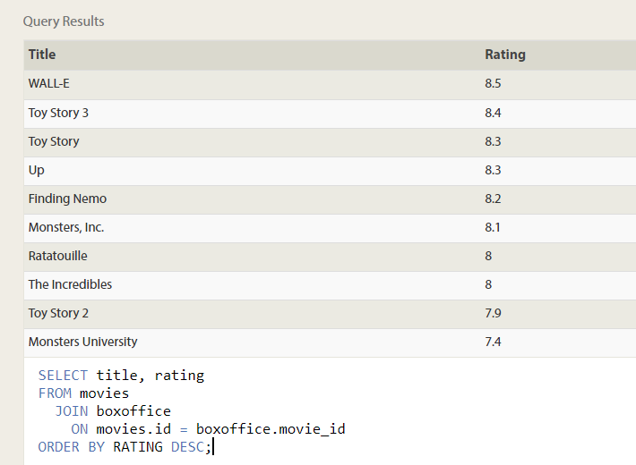

1. List of buildings that have employees

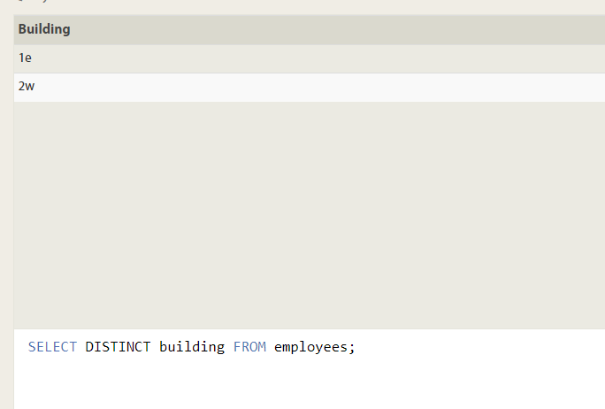

1. List of buildings and their capacity

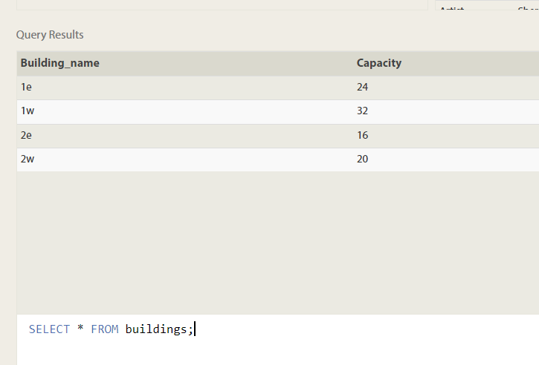

1. List of building and distinct employees

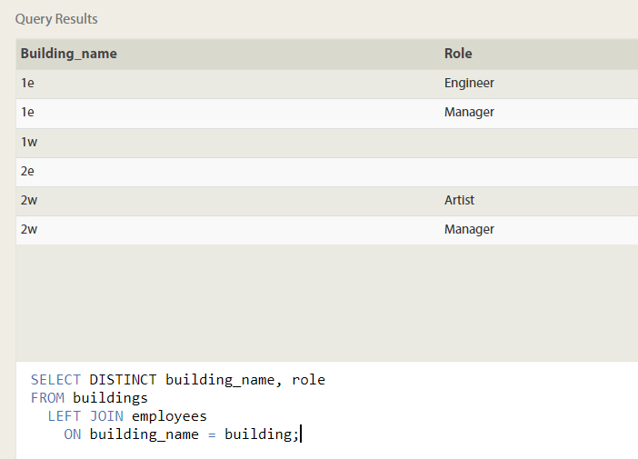

1. Employees who have not assigned buildings

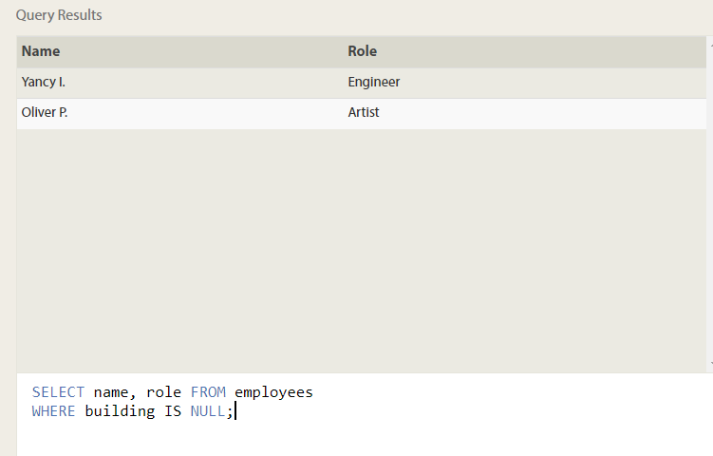

1. Name of building with no employees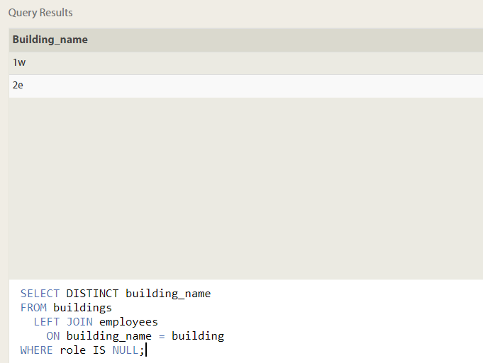
2. Movies with combined sale in million dollars

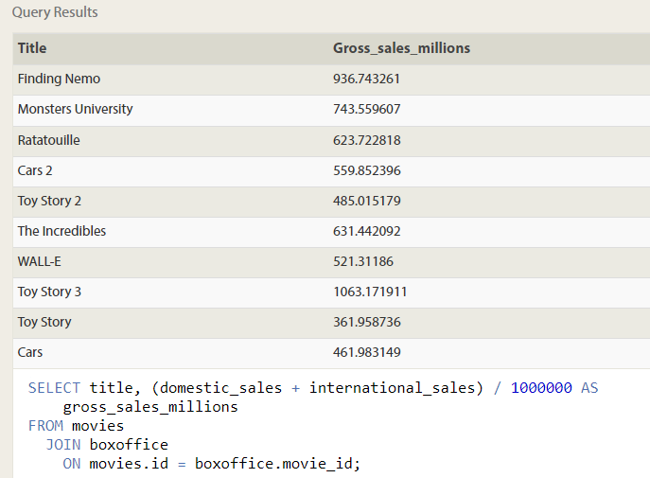

1. Movies and their ratings as percent

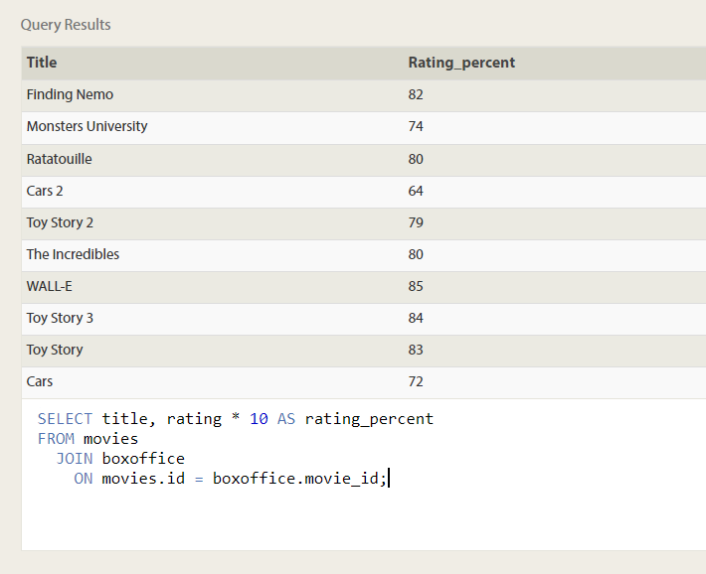

1. Movies released in even year

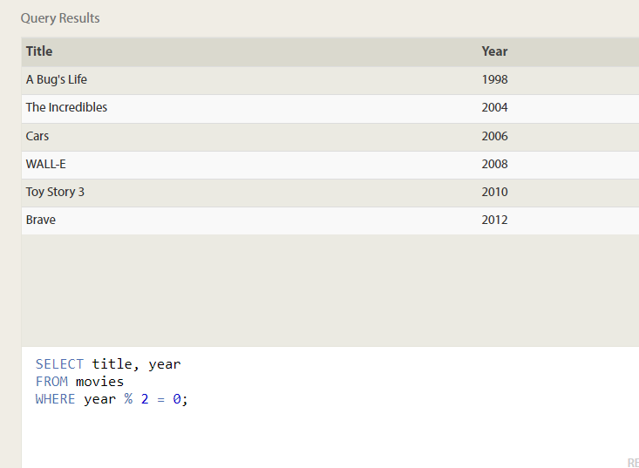

1. Longest time of employee in studio

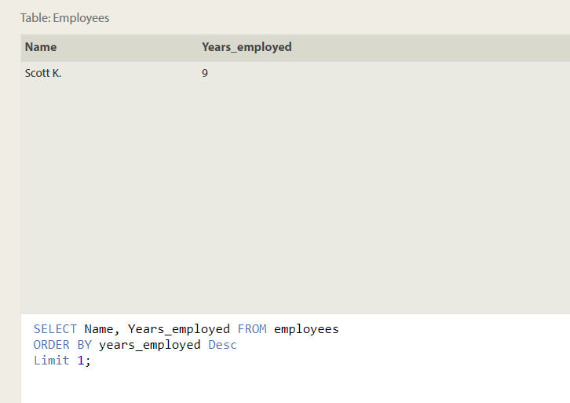

1. Average number of years for each role

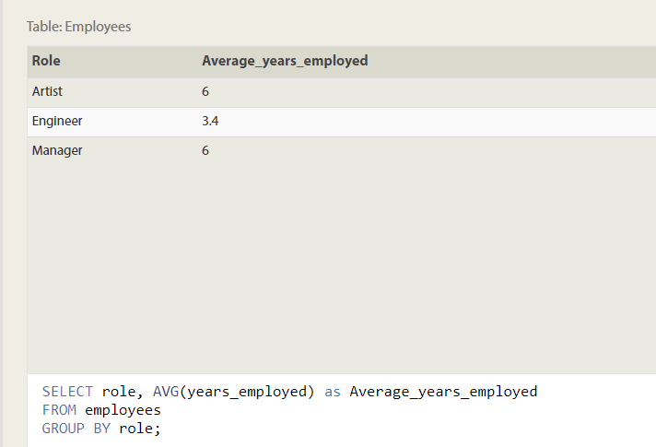

1. Total of employee years in each building

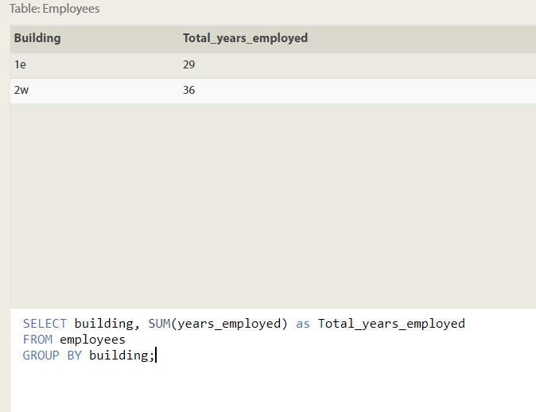

1. Number of artists in studio

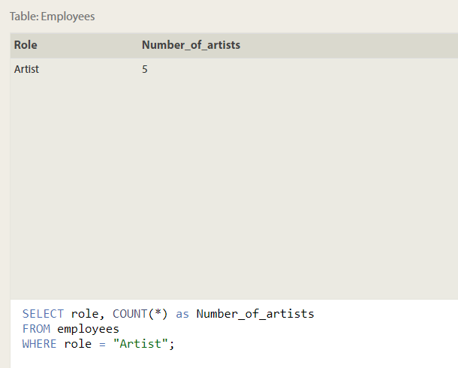

1. Number of employees in each role

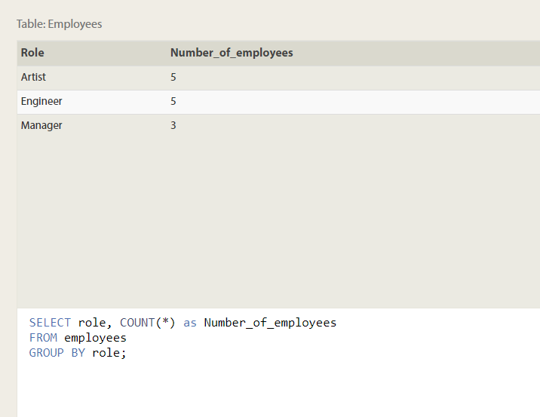

1. Total number of years by engineers

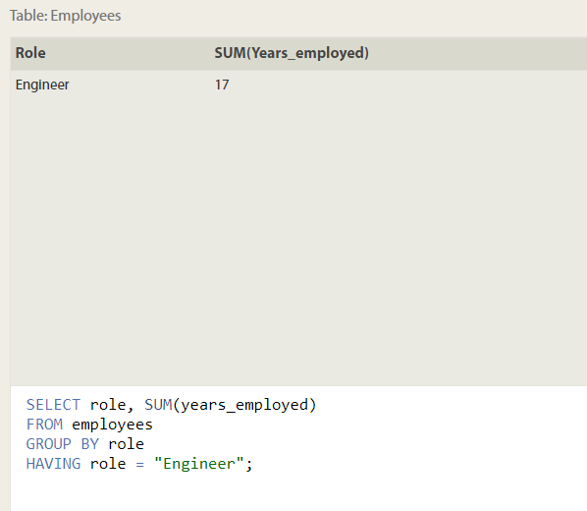

1. NUMBER OF MOVIES EACH DIRECTOR DIRECTED

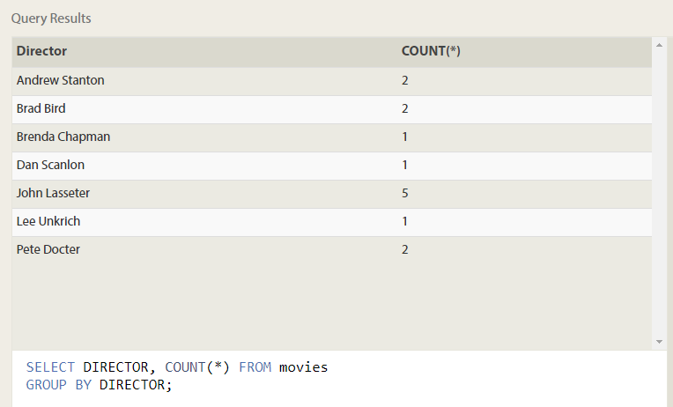

1. DOMESTIC AND INTERNATIONAL SALES ATTRIBUTED TO EACH DIRECTOR

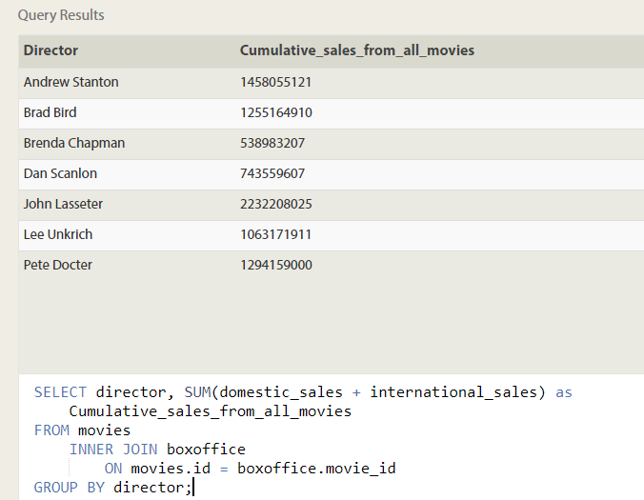

1. Insert toy story 4

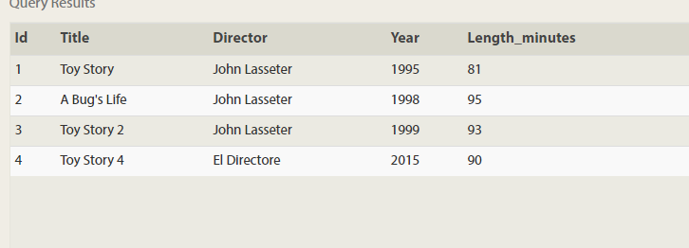

1. INSERT IN BOXOFFICE

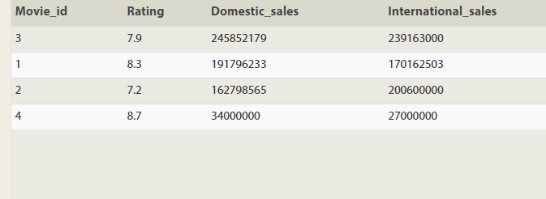

1. UPDATE DIRECTOR FOR MOVIE ID 2

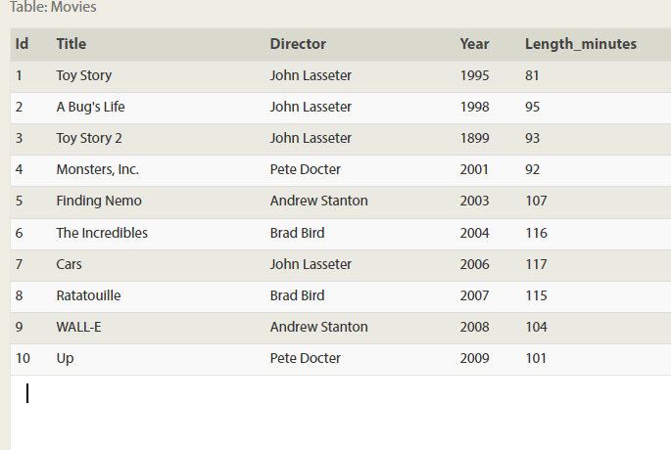

1. UPDATE TOYSTORY 2 YEAR AS 1999

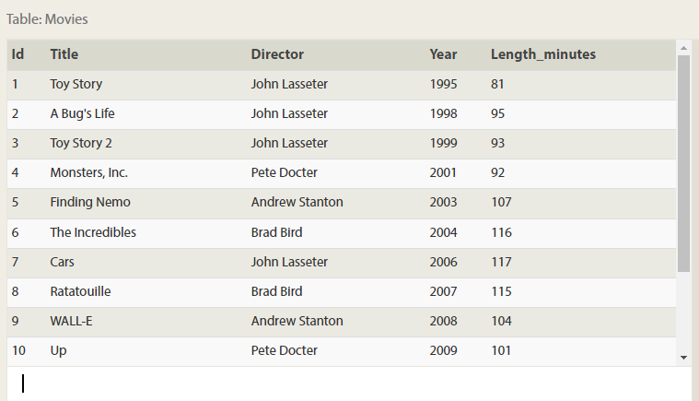

1. UPDATE TOY STORY 8

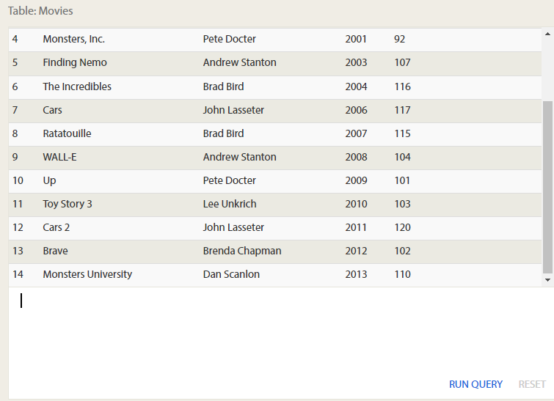

1. DELETE MOVIES RELEASED BEFORE 2005

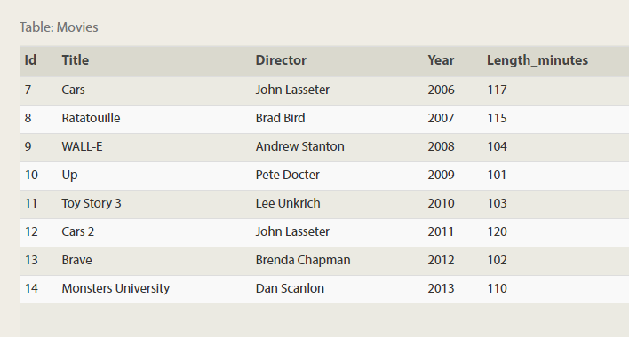

1. Delete movie directed by Andrew stanton

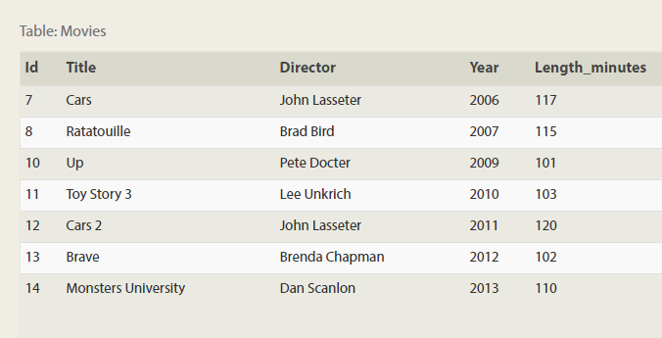

1. Creating a table database

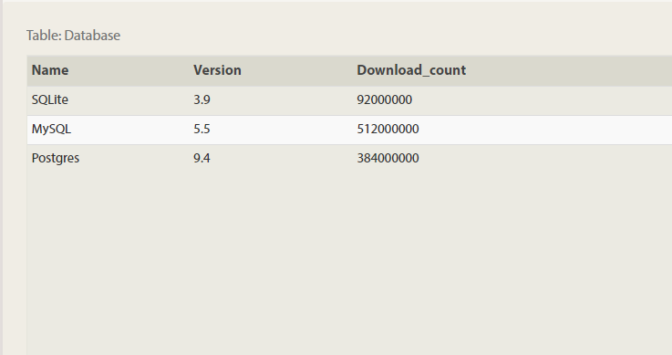

1. ADD NEW COLUMN ASPECT RATIO

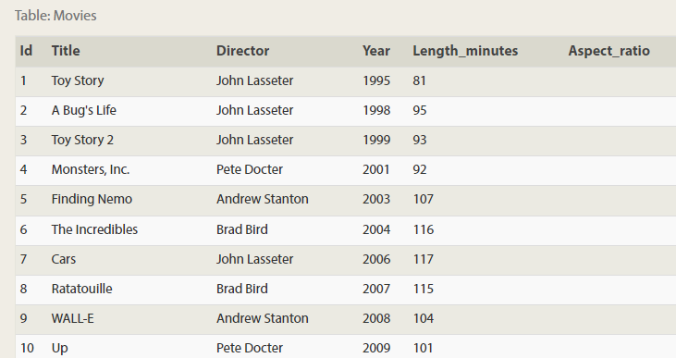

1. Add colum language with default value as English

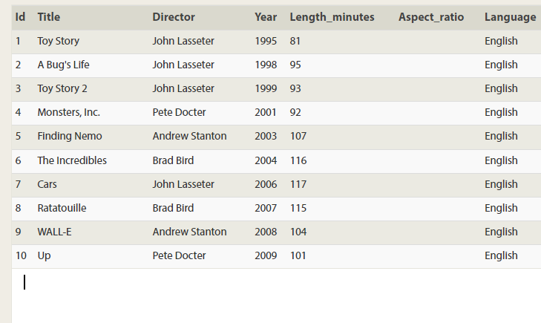

1. Drop table movies

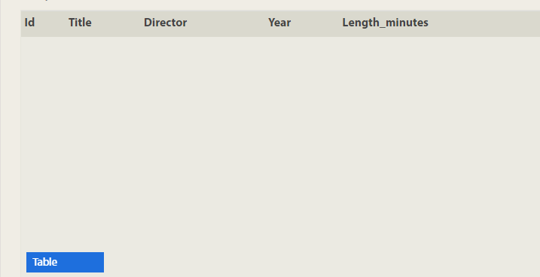

1. Drop table box office

